

**IE2060**

**Computer Systems Administration**

**2nd Year, 2nd Semester**

**Individual Assignment**

Submitted to

Sri Lanka Institute of Information Technology

In partial fulfillment of the requirements for the

Bachelor of Science Special Honors Degree in Information Technology

10th of April 2024

**Declaration**

I certify that this report does not incorporate without acknowledgement, any material previously submitted for a degree or diploma in any university, and to the best of my knowledge and belief it does not contain any material previously published or written by another person, except where due reference is made in text.

Registration Number : IT22571298

Name: P. Kashmira Anjalee Silva

# Contents

Contents iii

1. Installation and Configuration of Nagios Core on CentOS Server 6

1.1 Before installation, make sure that everything on the server is up to date by running the yum update command. This command will check repositories and notify you if anything needs to be updated. 6

2. Download Nagios Core and Nagios Plugin. 7

2.1 Nagios 7

3. Extract Nagios Core and its Plugins 7

4. Configure Nagios Core 8

5. The following command will install the init scripts for Nagios. 9

6. Install and Configure Web Interface for Nagios 11

7. Compile and Install Nagios Plugin 11

8. Verify Nagios Configuration Files 12

9. Add Nagios Services to System Startup 13

10. Adjusting the Firewall 13

11. Login to the Nagios Web Interface 13

12. Enabling HTTPS connection for the Apache Web Server 14

13. Installing Nagios Plugins and NRPE On Remote Linux Host 17

14. Install NRPE Plugin in Nagios 21

2. Configuring the Caching Name Server 26

Figure 1 Update the CentOS system. 8

Figure 2 New packages installed, and packages upgraded. 8

Figure 3 We need to install Apache, PHP and some libraries like gcc, glibc, glibc-common and GD libraries and its development libraries before installing Nagios 4.4.5 with the source. 8

Figure 4 Create a new nagios user using and group account and set a password 8

Figure 5 Next, add both the nagios user and the apache user to the nagcmd group 9

Figure 6 Create a directory for your Nagios installation and all its future downloads. 9

Figure 7 Now download latest Nagios Core 4.4.5 and Nagios plugins 2.2.1 packages 9

Figure 8 We need to extract downloaded packages with tar command as above 9

Figure 9 We need to extract downloaded packages with tar command as above, continued 10

Figure 10 When you extract these tarballs with tar command, two new folders will appear in that directory 10

Figure 11 we will configure Nagios Core and to do so we need to go to Nagios directory and run configure file and if everything goes fine, it will show the output in the end as sample output above 10

Figure 12 we will configure Nagios Core and to do so we need to go to Nagios directory and run configure file and if everything goes fine, it will show the output in the end as sample output above, continued 11

Figure 13 After configuring, we need to compile and install all the binaries with make all and make install command, it will install all the needed libraries in your machine and we can proceed further. 11

Figure 14 After configuring, we need to compile and install all the binaries with make all and make install command, it will install all the needed libraries in your machine and we can proceed further., continued 11

Figure 15To make Nagios work from command line we need to install command-mode. 11

Figure 16 Next, install sample Nagios files, please run following command 11

Figure 17 Next, install sample Nagios files, please run following command 12

Figure 18 Customizing Nagios Configuration 12

Figure 19 Open the “contacts.cfg” file with your choice of editor and set the email address associated with the nagiosadmin contact definition to receiving email alerts. 12

Figure 20 We are done with all configuration in the backend, now we will configure Web Interface For Nagios with the following command. 13

Figure 21 Then we will be creating a password for “nagiosadmin”. After executing this command, we need to provide a password twice (This password and user name will be used when you login in the Nagios Web interface.) 13

Figure 22 Now start and enable the Apache service 13

Figure 23 We have downloaded Nagios plugins in /root/nagios/nagios-plugins-2.2.1, change to the extracted directory. 13

Figure 24 Before building Nagios Plugins, we must configure it. 13

Figure 25 Then compile and Install Nagios Plugins 14

Figure 26 Then compile and Install Nagios Plugins,Continued 14

Figure 27 We've completed the Nagios configuration. Please enter the following command to Verify It. If everything is functioning properly, the output should resemble the example below. 14

Figure 28 To make Nagios work across reboots, we need to add nagios and httpd with chkconfig and systemctl command. 15

Figure 29 If Firewall service running on your server you need to open HTTP and HTTPS ports, 80 and 443 in firewall. 15

Figure 30 Nagios is prepared for operation. Access it through your web browser using either 'http://Your-server-IP-address/nagios' or 'http://FQDN/nagios', and then provide the username 'nagiosadmin' along with the password 15

Figure 31 Nagios is prepared for operation. Access it through your web browser using either 'http://Your-server-IP-address/nagios' or 'http://FQDN/nagios', and then provide the username 'nagiosadmin' along with the password 16

Figure 32 Install SSL in the Server 16

Figure 33 Create a private key for the website 16

Figure 34 Create Signing Request for the Website 17

Figure 35 Create the self-signed certificate which is valid for 365 days 17

Figure 36 Copy all the necessary files to the relevant locations 17

Figure 37 Set the Apache Web Server to use the created certificates by editing relevant lines in the ssl.conf file 18

Figure 38 Set the Apache Web Server to use the created certificates by editing relevant lines in the ssl.conf file continued 18

Figure 39 Restart the Apache Web Server to apply the changes 18

Figure 40 Verify It the SSL Certificate 19

Figure 41 Install required libraries On Client Host 19

Figure 42 Create a new nagios user account and set a password. 20

Figure 43 Now download the latest Nagios Plugins package 20

Figure 44 Extract Nagios Plugins 20

Figure 45 compile and install nagios plugins using the following commands 20

Figure 46 compile and install nagios plugins using the following commands continued 20

Figure 47 Set the permissions on the plugin directory 21

Figure 48 Install the nrpe plugin 21

Figure 49 Install the nrpe plugin, continued 21

Figure 50 Install the nrpe plugin, continuing the process 21

Figure 51 Install the NRPE plugin daemon, and sample config files 22

Figure 52 open /usr/local/nagios/etc/nrpe.cfg file and add the local host and IP address of the Nagios Monitoring Server 22

Figure 53 open /usr/local/nagios/etc/nrpe.cfg file and add the local host and IP address of the Nagios Monitoring Server, continued 22

Figure 54 enable and restart the nrpe service 22

Figure 55 verify the NRPE daemon is functioning properly by running 22

Figure 56 To install the nrpe plugin, first, download the latest NRPE Plugin or use the following wget command. 23

Figure 57 Unpack the NRPE source code tarball. 23

Figure 58 Compile and install the NRPE addon 23

Figure 59 Compile and install the NRPE addon, continued 23

Figure 60 Compile and install the NRPE addon, continued further 24

Figure 61 Next, install the NRPE plugin daemon, and sample config files. 24

Figure 62 Install the NRPE daemon under systemd as a service. 24

Figure 63 Creating Nagios Host and Services File 24

Figure 64 Now add these two files to the main Nagios configuration file. Open the nagios.cfg file with any editor. 24

Figure 65 Configuring Nagios Host and Services File 25

Figure 66 Configuring Nagios Host and Services File, continued 25

Figure 67 Configuring NRPE Command Definition 26

Figure 68 verify Nagios Configuration files for any errors 26

Figure 69 restart Nagios to apply recent configuration changes 27

Figure 70 Monitoring Remote Linux in Nagios 27

Figure 71 instructing the system to set the hostname of the machine , After executing this command and rebooting the system , the new hostname will be applied to the machine 28

Figure 72 provide you with information about the current status of the systemd-hostnamed service, including whether it's active, its process ID (PID), any recent logs, and any errors or warnings encountered 28

Figure 73 To view the current hostname of your system, 28

Figure 74 to display the fully qualified domain name (FQDN) of the system 29

Figure 75 open superuser privileges, allowing you to make changes to the file. You can then add or modify entries in the file as needed. 29

Figure 76 open superuser privileges, allowing you to make changes to the file. You can then add or modify entries in the file as needed. continued 29

Figure 77 display the contents of DNS servers, search domains, and other options related to DNS resolution configured on your system. 29

Figure 78 systemctl status named’ to check the status of the BIND (Berkeley Internet Name Domain) service on your system. 30

Figure 79 Editing the Main DNS Configuration File in /etc/named.conf Location 31

Figure 80 Editing the Main DNS Configuration File in /etc/named.conf Location, continued 31

Figure 81 going to inside of the directory called ‘forward.csa.lk’, Adding the zones 32

Figure 82 going to inside of the directory called ‘forward.csa.lk’, adding the zones, continued 32

Figure 83 going to inside of the directory called ‘forward.csa.lk’, adding the zones, further ontinued 33

Figure 84 going to inside of the directory called ‘reverse.csa.lk’ 33

Figure 85 going to inside of the directory called ‘reverse.csa.lk’, adding zones, futher continued 34

Figure 86 sudo fire wall command 34



# Installation and Configuration of Nagios Core on CentOS Server

## Before installation, make sure that everything on the server is up to date by running the yum update command. This command will check repositories and notify you if anything needs to be updated.

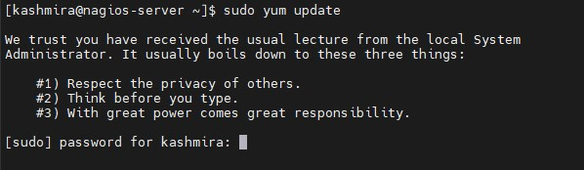

Figure 1 Update the CentOS system.

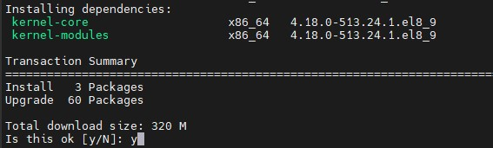

Figure 2 New packages installed, and packages upgraded.

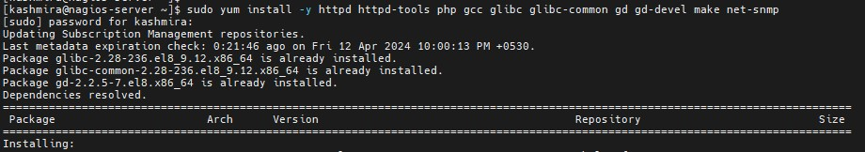

Figure 3 We need to install Apache, PHP and some libraries like gcc, glibc, glibc-common and GD libraries and its development libraries before installing Nagios 4.4.5 with the source.



Figure 4 Create a new nagios user using and group account and set a password

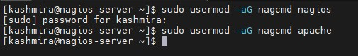

Figure 5 Next, add both the nagios user and the apache user to the nagcmd group

# Download Nagios Core and Nagios Plugin.

## 2.1 Nagios

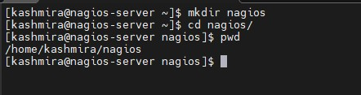

Figure 6 Create a directory for your Nagios installation and all its future downloads.

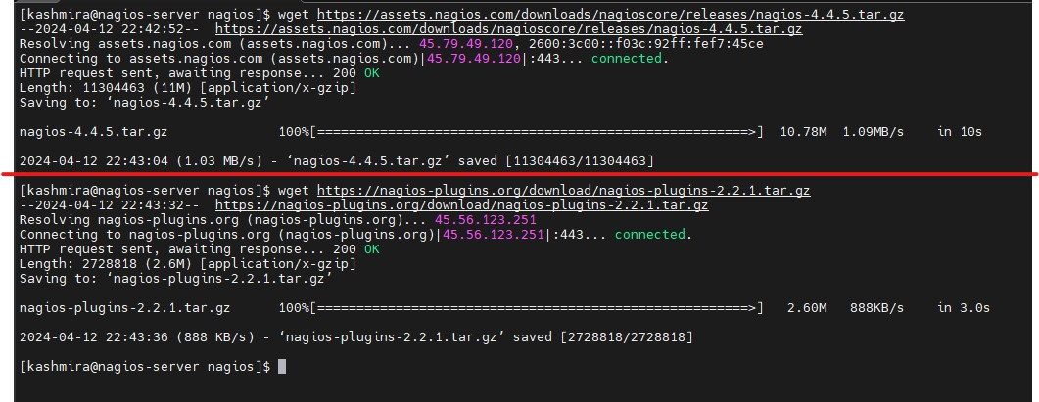

Figure 7 Now download latest Nagios Core 4.4.5 and Nagios plugins 2.2.1 packages

# Extract Nagios Core and its Plugins

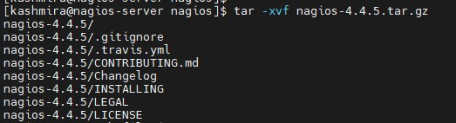

Figure 8 We need to extract downloaded packages with tar command as above

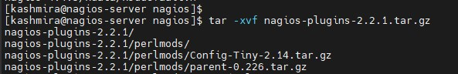

Figure 9 We need to extract downloaded packages with tar command as above, continued

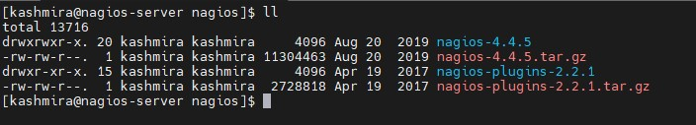

Figure 10 When you extract these tarballs with tar command, two new folders will appear in that directory

# Configure Nagios Core

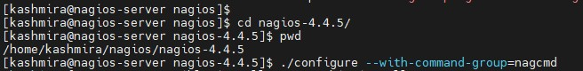

Figure 11 we will configure Nagios Core and to do so we need to go to Nagios directory and run configure file and if everything goes fine, it will show the output in the end as sample output above

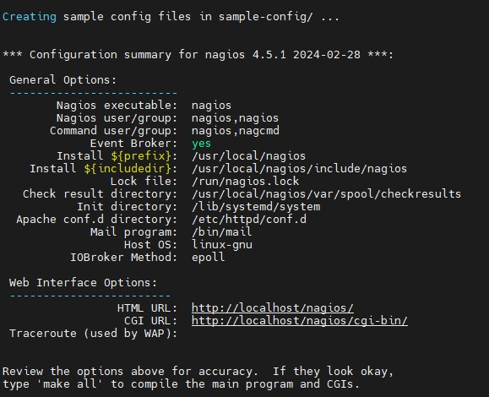

Figure 12 we will configure Nagios Core and to do so we need to go to Nagios directory and run configure file and if everything goes fine, it will show the output in the end as sample output above, continued

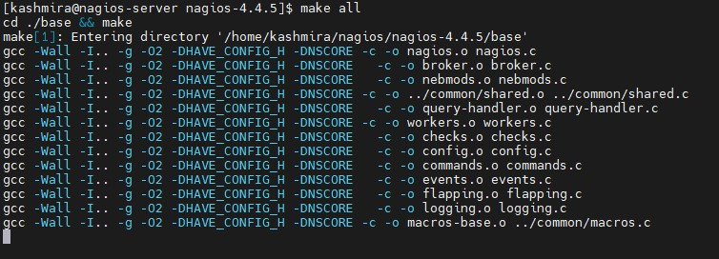

Figure 13 After configuring, we need to compile and install all the binaries with make all and make install command, it will install all the needed libraries in your machine and we can proceed further.

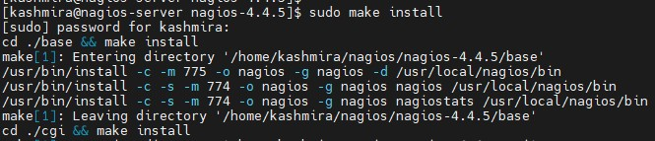

Figure 14 After configuring, we need to compile and install all the binaries with make all and make install command, it will install all the needed libraries in your machine and we can proceed further., continued

# The following command will install the init scripts for Nagios.



Figure 15To make Nagios work from command line we need to install command-mode.

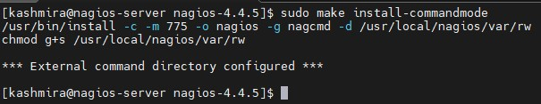

Figure 16 Next, install sample Nagios files, please run following command

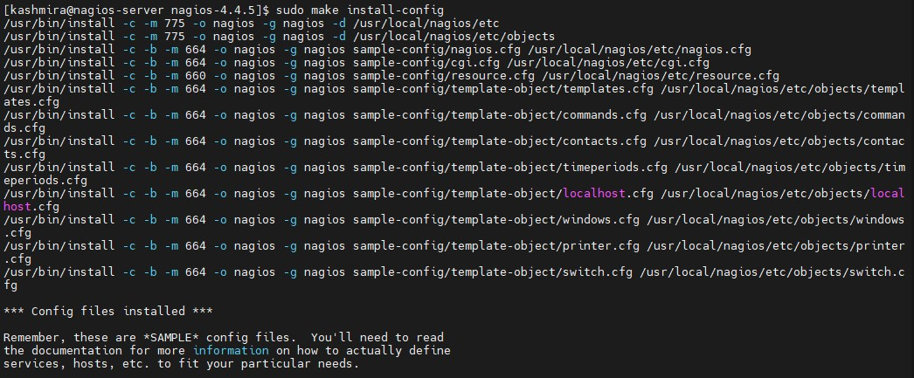

Figure 17 Next, install sample Nagios files, please run following command



Figure 18 Customizing Nagios Configuration

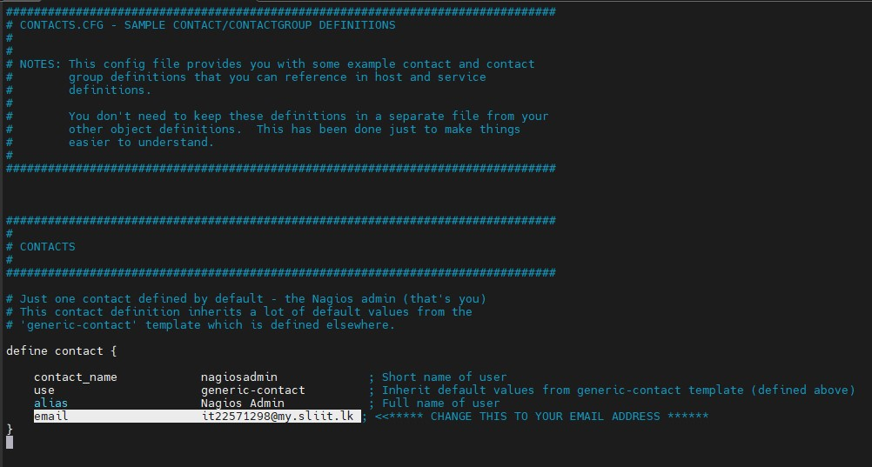

Figure 19 Open the “contacts.cfg” file with your choice of editor and set the email address associated with the nagiosadmin contact definition to receiving email alerts.

# Install and Configure Web Interface for Nagios

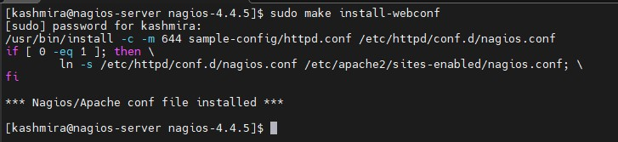

Figure 20 We are done with all configuration in the backend, now we will configure Web Interface For Nagios with the following command.

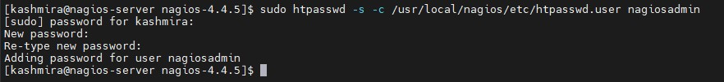

Figure 21 Then we will be creating a password for “nagiosadmin”. After executing this command, we need to provide a password twice (This password and user name will be used when you login in the Nagios Web interface.)

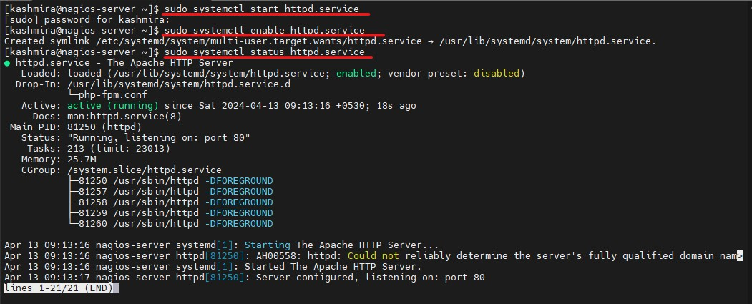

Figure 22 Now start and enable the Apache service

# Compile and Install Nagios Plugin



Figure 23 We have downloaded Nagios plugins in /root/nagios/nagios-plugins-2.2.1, change to the extracted directory.



Figure 24 Before building Nagios Plugins, we must configure it.



Figure 25 Then compile and Install Nagios Plugins

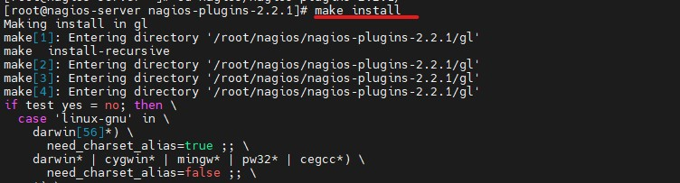

Figure 26 Then compile and Install Nagios Plugins,Continued

# Verify Nagios Configuration Files

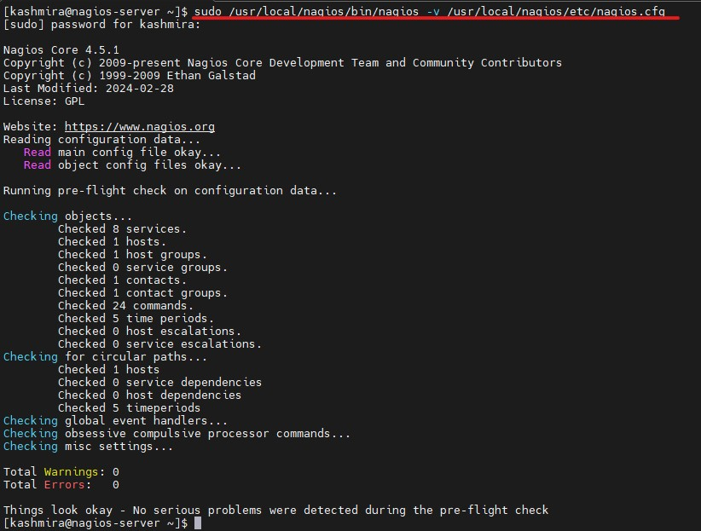

Figure 27 We've completed the Nagios configuration. Please enter the following command to Verify It. If everything is functioning properly, the output should resemble the example below.

# Add Nagios Services to System Startup

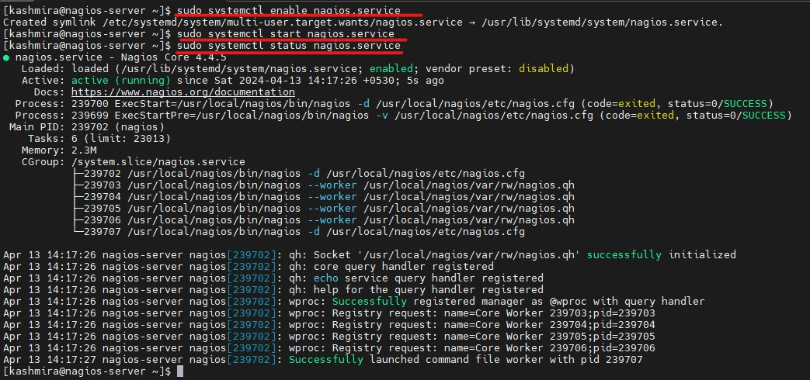

Figure 28 To make Nagios work across reboots, we need to add nagios and httpd with chkconfig and systemctl command.

# Adjusting the Firewall

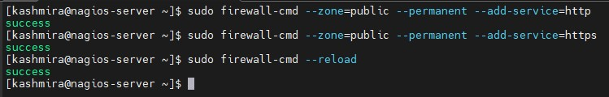

Figure 29 If Firewall service running on your server you need to open HTTP and HTTPS ports, 80 and 443 in firewall.

# Login to the Nagios Web Interface

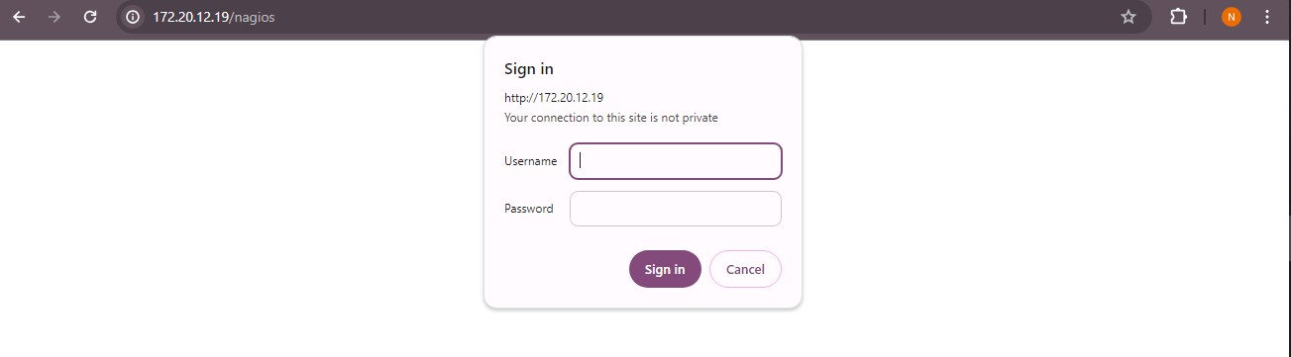

Figure 30 Nagios is prepared for operation. Access it through your web browser using either 'http://Your-server-IP-address/nagios' or 'http://FQDN/nagios', and then provide the username 'nagiosadmin' along with the password

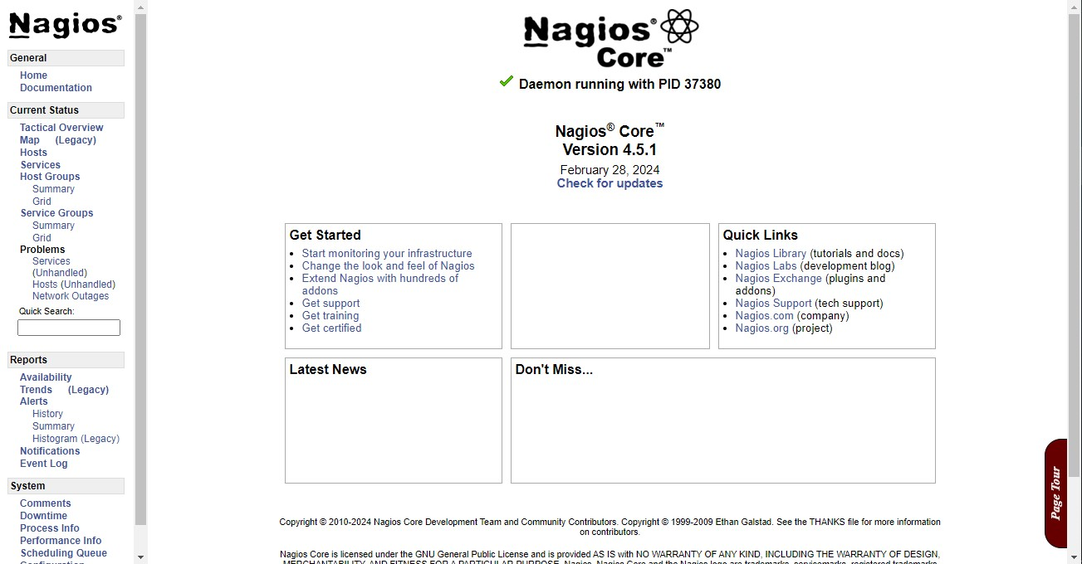

Figure 31 Nagios is prepared for operation. Access it through your web browser using either 'http://Your-server-IP-address/nagios' or 'http://FQDN/nagios', and then provide the username 'nagiosadmin' along with the password

# Enabling HTTPS connection for the Apache Web Server

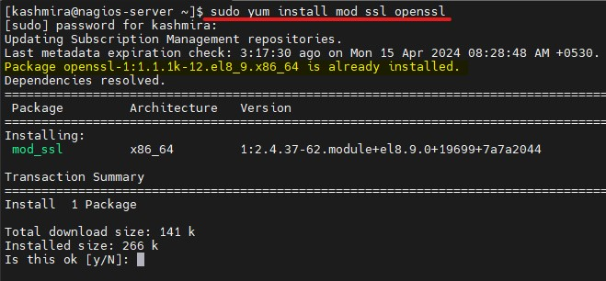

Figure 32 Install SSL in the Server

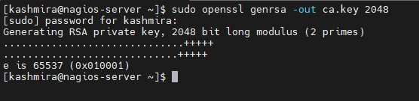

Figure 33 Create a private key for the website

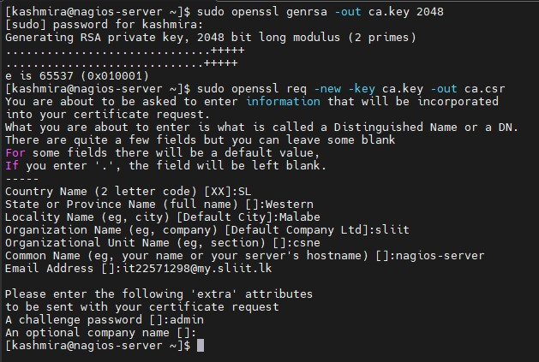

Figure 34 Create Signing Request for the Website

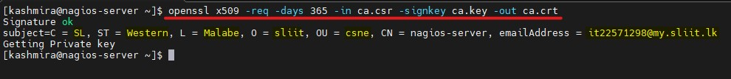

Figure 35 Create the self-signed certificate which is valid for 365 days

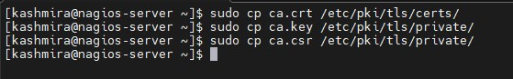

Figure 36 Copy all the necessary files to the relevant locations

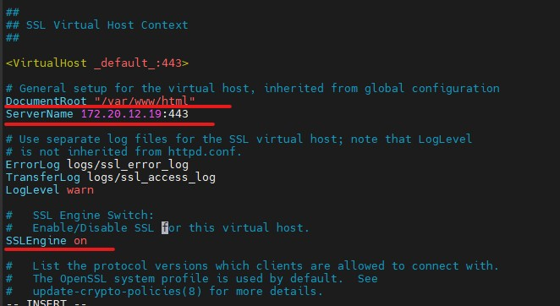

Figure 37 Set the Apache Web Server to use the created certificates by editing relevant lines in the ssl.conf file

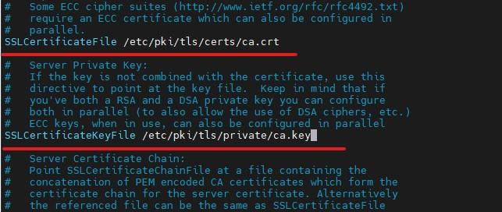

Figure 38 Set the Apache Web Server to use the created certificates by editing relevant lines in the ssl.conf file continued

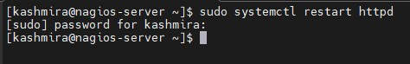

Figure 39 Restart the Apache Web Server to apply the changes

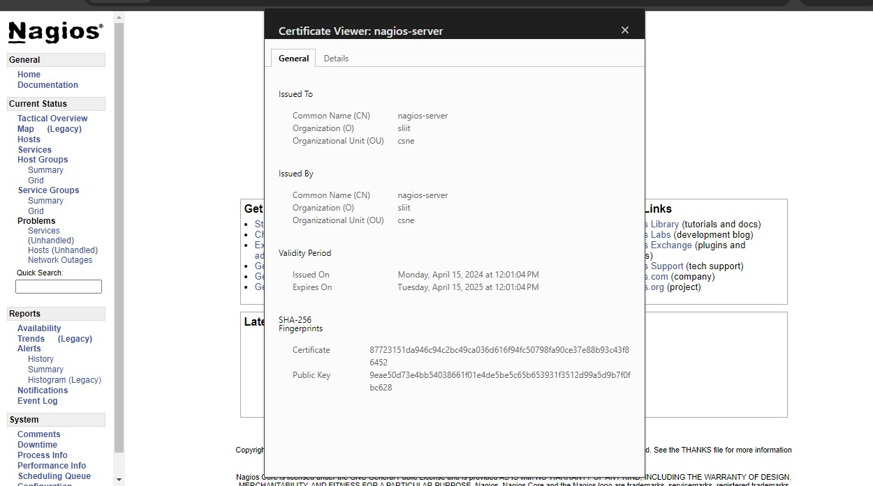

Figure 40 Verify It the SSL Certificate

# Installing Nagios Plugins and NRPE On Remote Linux Host

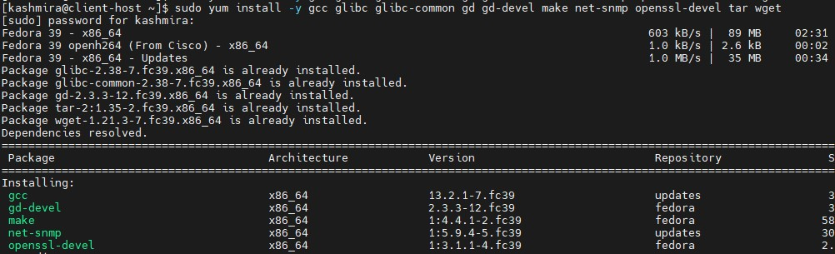

Figure 41 Install required libraries On Client Host

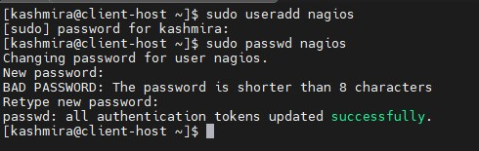

Figure 42 Create a new nagios user account and set a password.

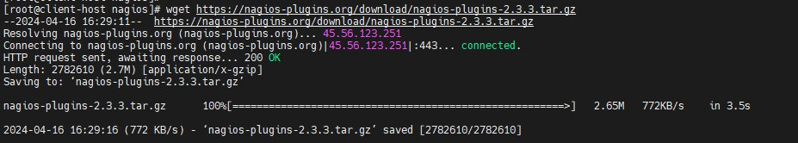

Figure 43 Now download the latest Nagios Plugins package

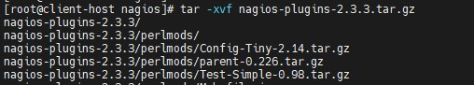

Figure 44 Extract Nagios Plugins

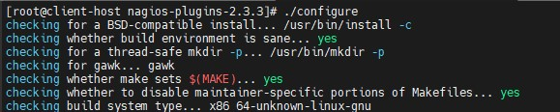

Figure 45 compile and install nagios plugins using the following commands

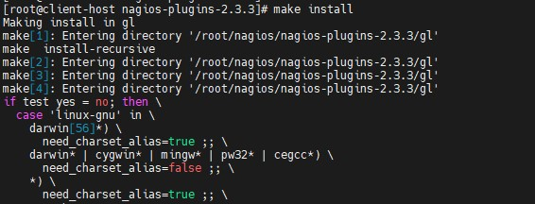

Figure 46 compile and install nagios plugins using the following commands continued

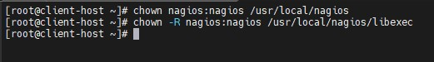

Figure 47 Set the permissions on the plugin directory

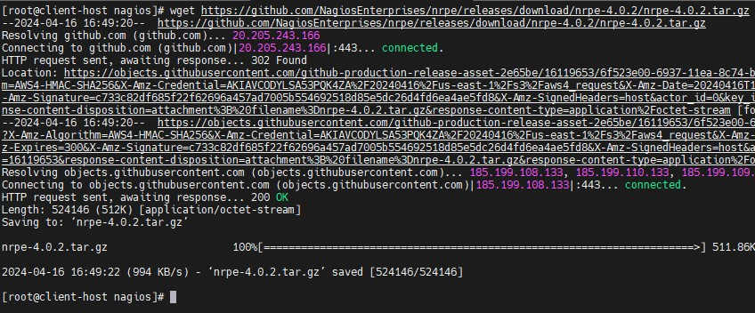

Figure 48 Install the nrpe plugin

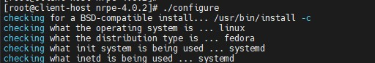

Figure 49 Install the nrpe plugin, continued

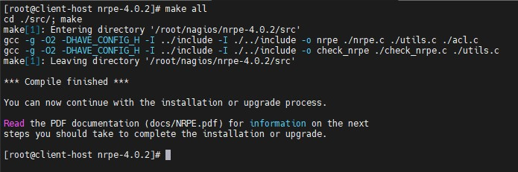

Figure 50 Install the nrpe plugin, continuing the process

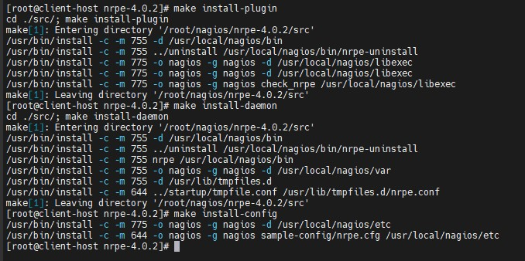

Figure 51 Install the NRPE plugin daemon, and sample config files



Figure 52 open /usr/local/nagios/etc/nrpe.cfg file and add the local host and IP address of the Nagios Monitoring Server

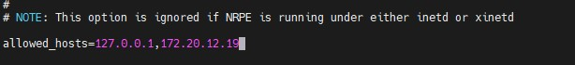

Figure 53 open /usr/local/nagios/etc/nrpe.cfg file and add the local host and IP address of the Nagios Monitoring Server, continued



Figure 54 enable and restart the nrpe service



Figure 55 verify the NRPE daemon is functioning properly by running

# Install NRPE Plugin in Nagios

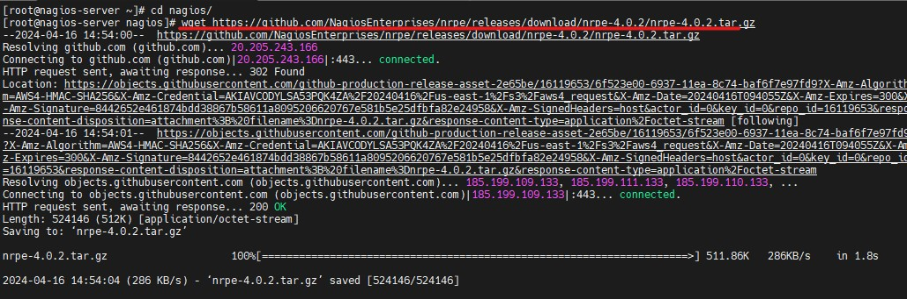

Figure 56 To install the nrpe plugin, first, download the latest NRPE Plugin or use the following wget command.

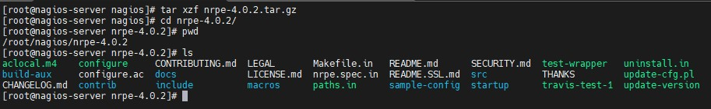

Figure 57 Unpack the NRPE source code tarball.

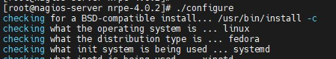

Figure 58 Compile and install the NRPE addon

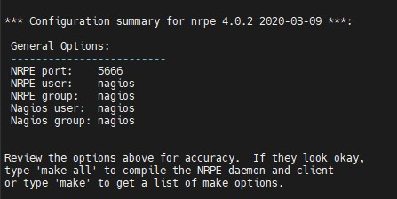

Figure 59 Compile and install the NRPE addon, continued

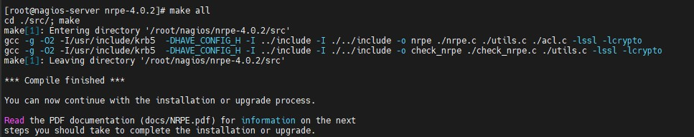

Figure 60 Compile and install the NRPE addon, continued further

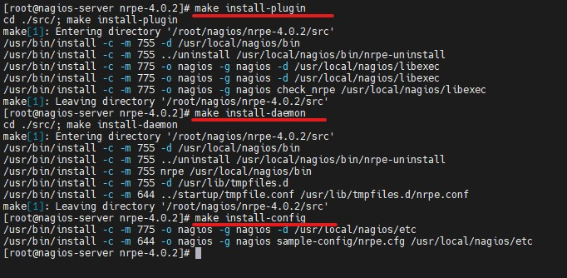

Figure 61 Next, install the NRPE plugin daemon, and sample config files.



Figure 62 Install the NRPE daemon under systemd as a service.

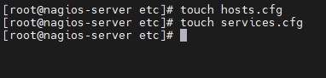

Figure 63 Creating Nagios Host and Services File

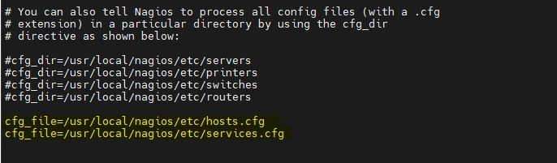

Figure 64 Now add these two files to the main Nagios configuration file. Open the nagios.cfg file with any editor.

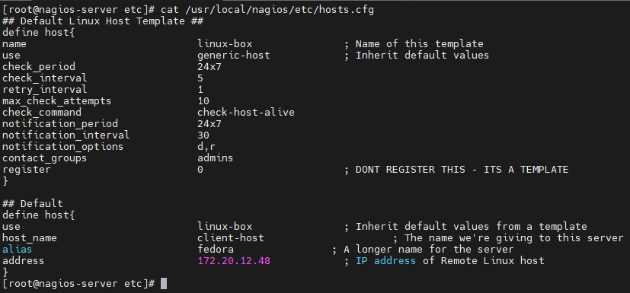

Figure 65 Configuring Nagios Host and Services File

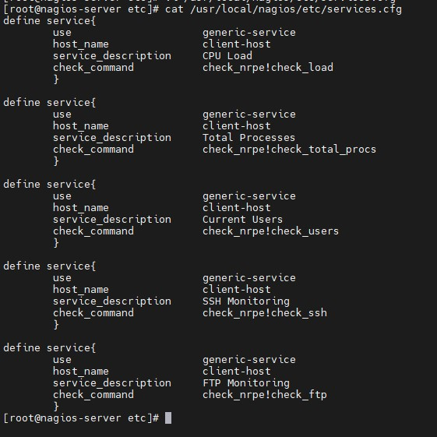

Figure 66 Configuring Nagios Host and Services File, continued

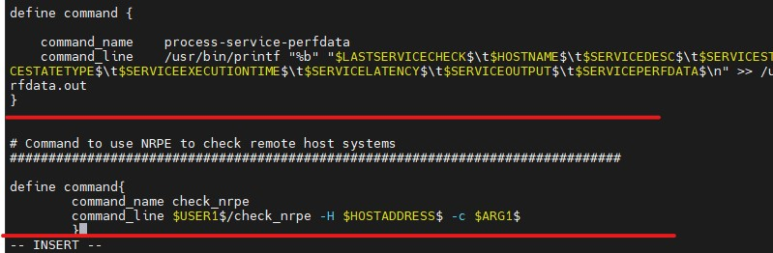

Figure 67 Configuring NRPE Command Definition

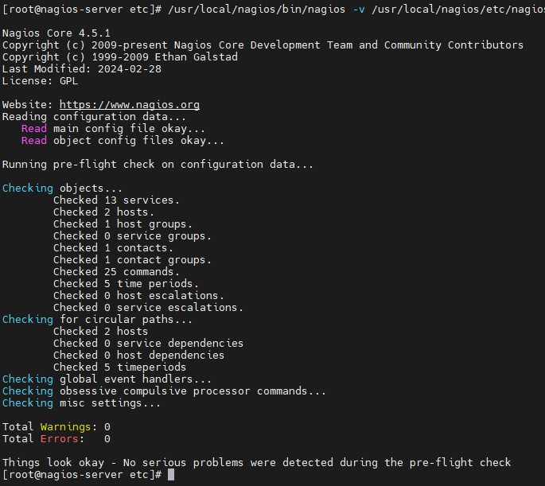

Figure 68 verify Nagios Configuration files for any errors



Figure 69 restart Nagios to apply recent configuration changes

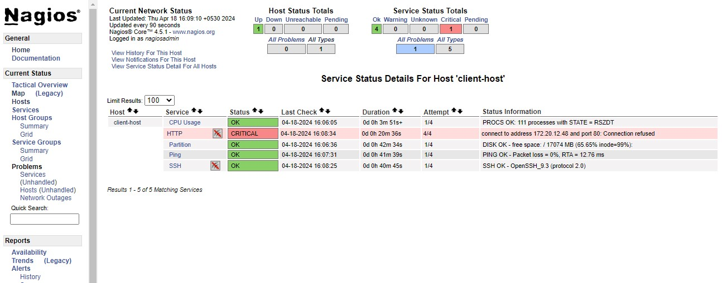

Figure 70 Monitoring Remote Linux in Nagios

# 2. Configuring the Caching Name Server



Figure 71 instructing the system to set the hostname of the machine , After executing this command and rebooting the system , the new hostname will be applied to the machine

used to restart the systemd-hostnamed service on a Linux system. This service is responsible for managing the hostname of the system. When you restart this service, any changes made to the hostname configuration will take effect.

Figure 72 provide you with information about the current status of the systemd-hostnamed service, including whether it's active, its process ID (PID), any recent logs, and any errors or warnings encountered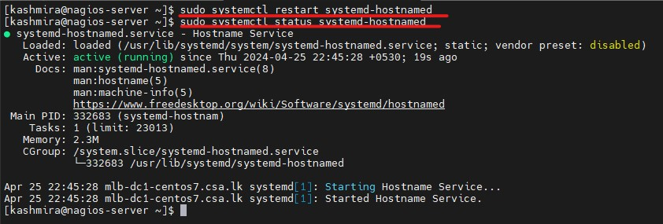

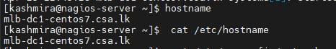

Figure 73 To view the current hostname of your system,

2.4 display the fully qualified domain name (FQDN) of the system.

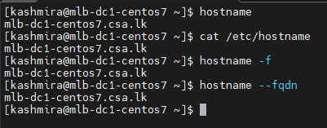

Figure 74 to display the fully qualified domain name (FQDN) of the system

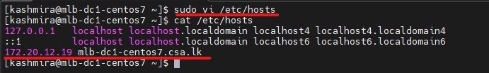

Figure 75 open superuser privileges, allowing you to make changes to the file. You can then add or modify entries in the file as needed.

Figure 76 open superuser privileges, allowing you to make changes to the file. You can then add or modify entries in the file as needed.

Figure 77 display the contents of DNS servers, search domains, and other options related to DNS resolution configured on your system.

‘systemctl status named’ to check the status of the BIND (Berkeley Internet Name Domain) service on your system.

‘sudo service named start’ used to start the BIND (Berkeley Internet Name Domain) service on your system.

‘sudo systemctl status named’ command will display the current status of the named service, indicating whether it's enabled to start at boot time or not.

‘service named status’ display information about the status of the BIND service, indicating whether it's running or not.

Figure 78 systemctl status named’ to check the status of the BIND (Berkeley Internet Name Domain) service on your system.

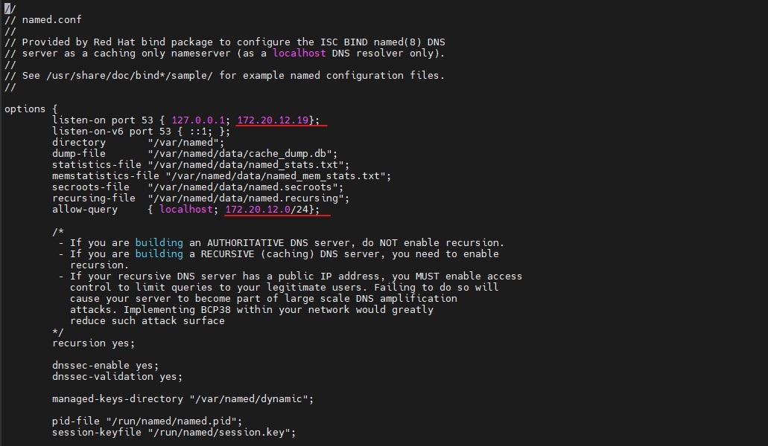Figure 79 Editing the Main DNS Configuration File in /etc/named.conf Location

Figure 80 Editing the Main DNS Configuration File in /etc/named.conf Location, continued

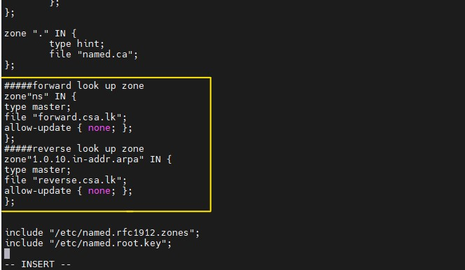

Adding the zones



Figure 81 going to inside of the directory called ‘forward.csa.lk’, Adding the zones

Figure 82 going to inside of the directory called ‘forward.csa.lk’, adding the zones, continued

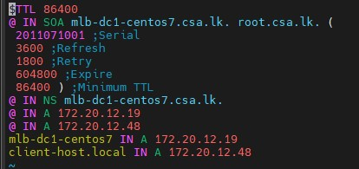

Figure 83 going to inside of the directory called ‘forward.csa.lk’, adding the zones, further ontinued



Figure 84 going to inside of the directory called ‘reverse.csa.lk’

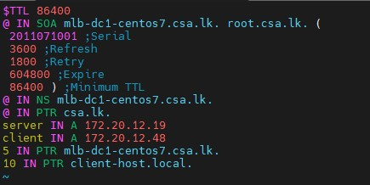

Figure 85 going to inside of the directory called ‘reverse.csa.lk’, adding zones, futher continued

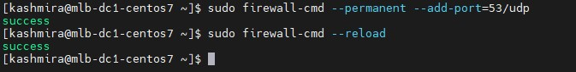

Figure 86 sudo fire wall command

Thank you